Jenkins migration to Harness - LAB

chart=jenkinsci/jenkins
helm install jenkins -n jenkins -f jenkins-values.yaml $chart

λ chart=jenkinsci/jenkins
helm install jenkins -n jenkins -f jenkins-values.yaml $chart
NAME: jenkins
LAST DEPLOYED: Thu Nov 27 13:12:45 2025
NAMESPACE: jenkins
STATUS: deployed
REVISION: 1
NOTES:
1. Get your 'admin' user password by running:
kubectl exec --namespace jenkins -it svc/jenkins -c jenkins -- /bin/cat /run/secrets/additional/chart-admin-password && echo
MzufylCYwsWDk72DxVnBz3
2. Get the Jenkins URL to visit by running these commands in the same shell:
echo http://127.0.0.1:8080
kubectl --namespace jenkins port-forward svc/jenkins 8080:8080

3. Login with the password from step 1 and the username: admin
4. Configure security realm and authorization strategy
5. Use Jenkins Configuration as Code by specifying configScripts in your values.yaml file, see documentation: http://127.0.0.1:8080/configuration-as-code and examples: https://github.com/jenkinsci/configuration-as-code-plugin/tree/master/demos

For more information on running Jenkins on Kubernetes, visit:
https://cloud.google.com/solutions/jenkins-on-container-engine

For more information about Jenkins Configuration as Code, visit:
https://jenkins.io/projects/jcasc/

NOTE: Consider using a custom image with pre-installed plugins

Jenkins migration
https://github.com/harness-community/jenkins-migration-binary/tree/main

How to Install:
- Download the Harness Migration Plugin from the releases section of this repository. For the best experience, we recommend using the latest release.
- Go To Manage Jenkins -> Plugins
- On the sidebar, choose Advanced settings.
- Click on Choose File and select the downloaded .hpi file.
- Click Deploy.

HARNESS MIGRATION TOOL CONFIGURATION ON JENKINS

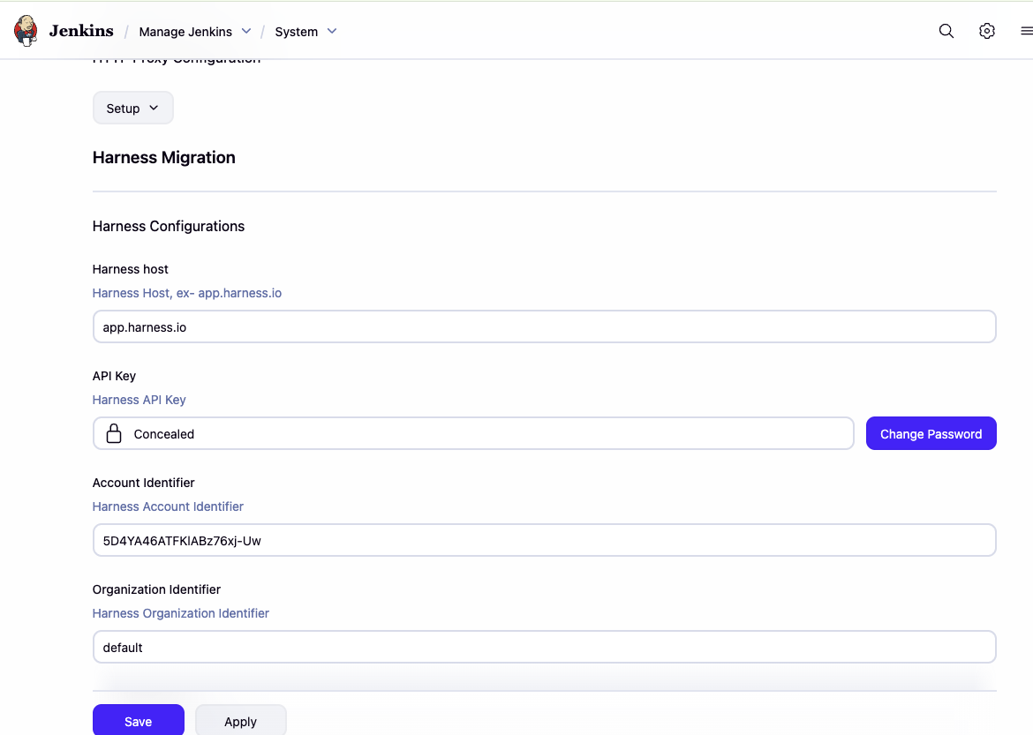

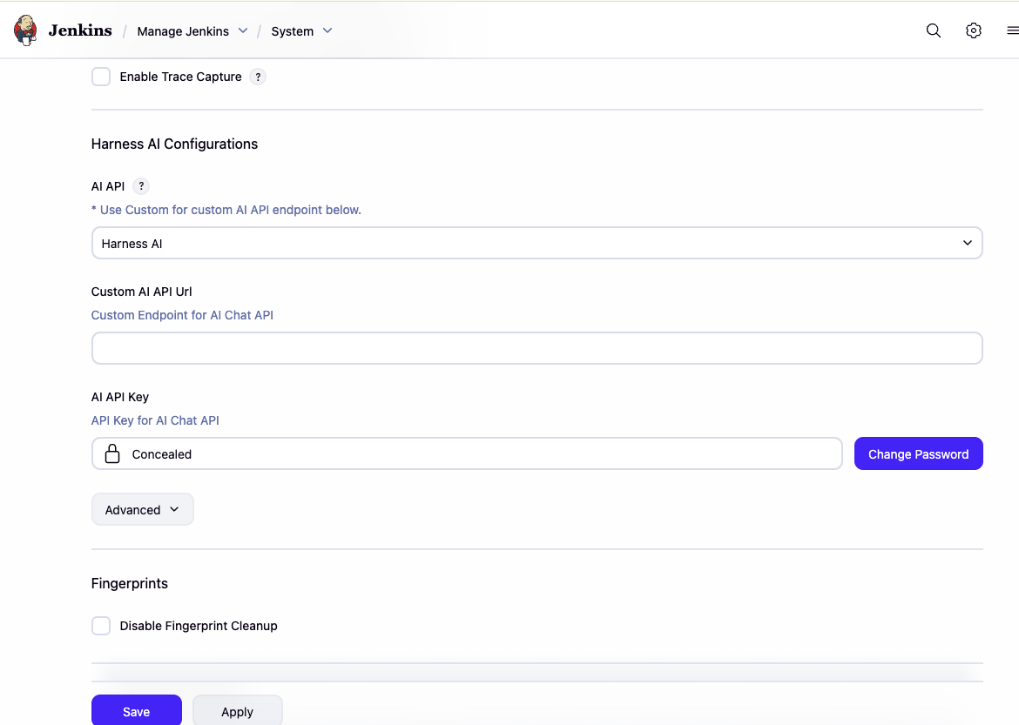

Error
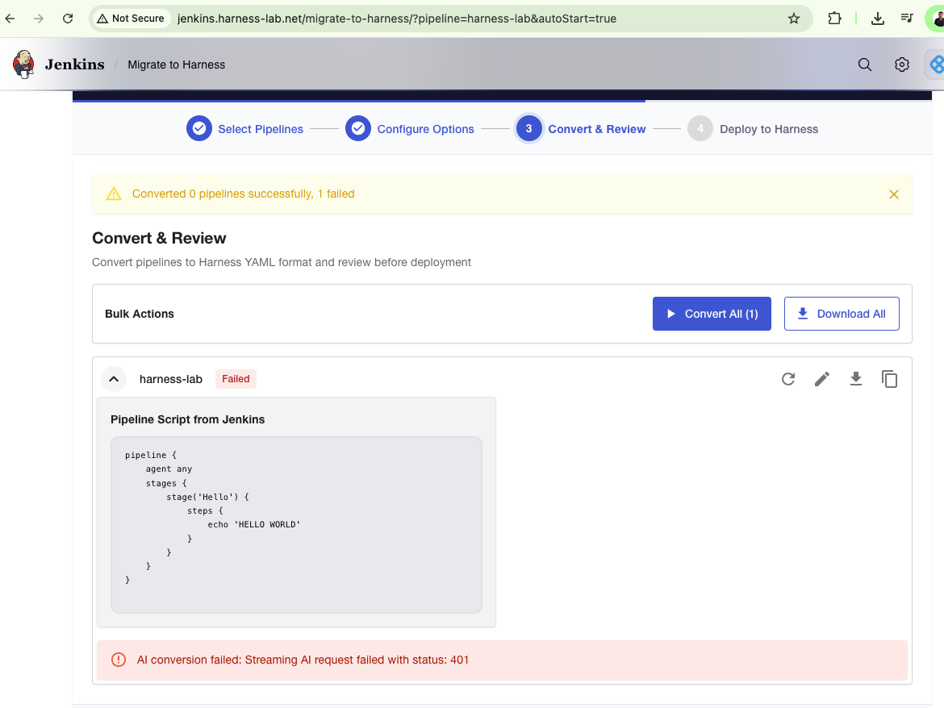
Or:
AI conversion failed: Streaming AI request failed with status: 500

SOLUTION:
Update the AI API Key with the same Harness Key used above.

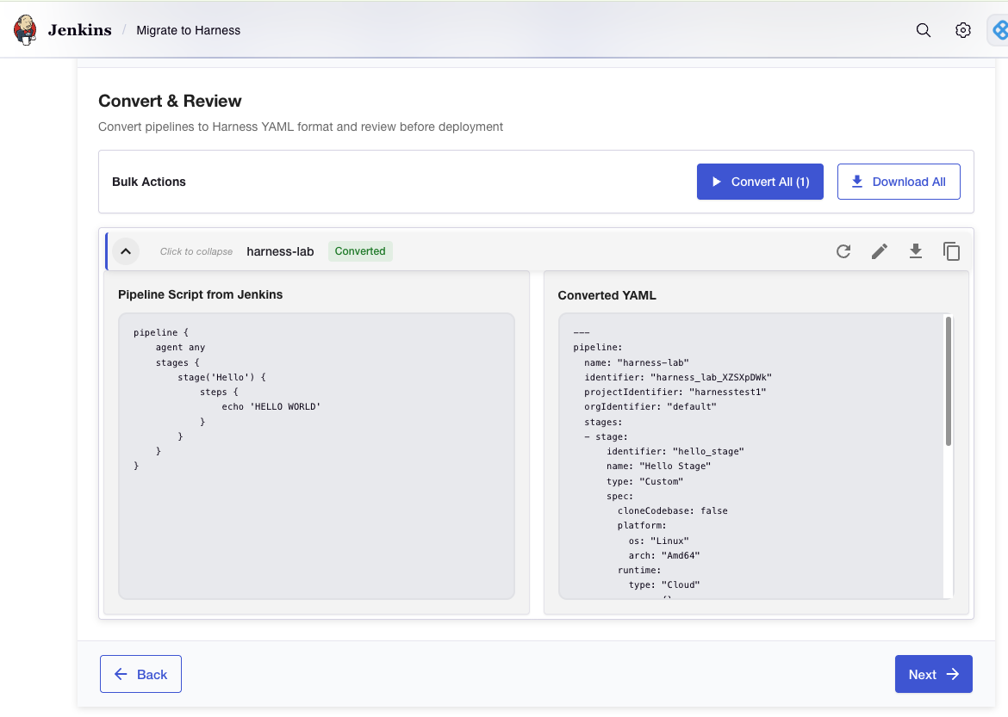

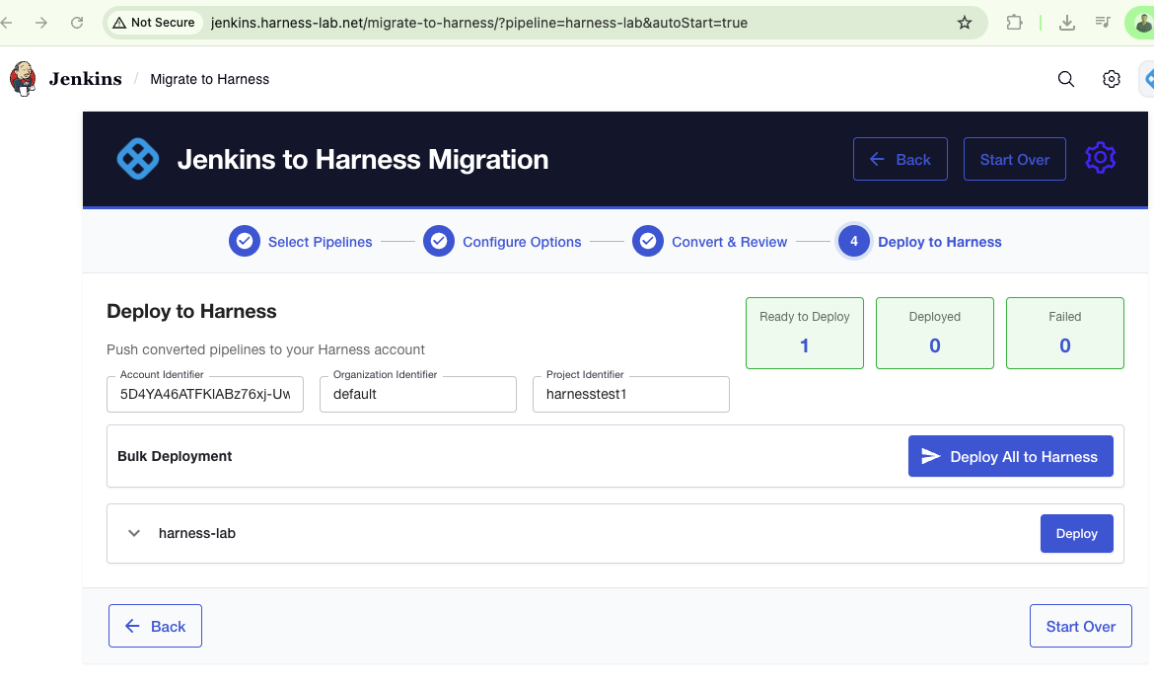
Deploy it and Open in Harness

ERROR
Failed to convert GP-lzVTK8JenkinsPipeline: AI conversion failed: Streaming AI request failed with status: 401

— My API Keys / default

Tk
pat.5D4YA46ATFKlABz76xj-Uw.69a745ea430847080a7acac8.gJSN8rzPu4x2OODjLP8i
pat.5D4YA46ATFKlABz76xj-Uw.69a745ea430847080a7acac8.gJSN8rzPu4x2OODjLP8i

